PROJECT REPORT
The Global Launch: Static Portfolio Website using Azure Storage
Cloud Computing / Azure Static Website Hosting Project
GitHub Repository Link: Paste your GitHub link here
Live Azure Website Link: Paste your Azure Primary Endpoint URL here

Table of Contents
1. Introduction
2. Project Objective
3. Tools and Technologies Used
4. Project Files and Formats
5. Project Folder Structure
6. Step-by-Step Implementation
7. Azure Deployment Steps
8. GitHub Repository Setup
9. Screenshots / Evidence
10. Links
11. Conclusion
12. Appendix: CSS Code

1. Introduction
This project is based on creating and deploying a static portfolio website using Microsoft Azure Storage. A static website contains fixed files such as HTML and CSS. In this project, the website was developed using HTML and CSS and then hosted online using Azure Static Website Hosting.
The project demonstrates how cloud storage can be used to publish a simple website without managing a traditional web server. The final website can be accessed globally through the Azure Primary Endpoint URL.

2. Project Objective
The main objective of this project is to understand how a static website can be hosted on Microsoft Azure without using a traditional server. The project also explains how to arrange project files properly, document the project using README.md, upload the project to GitHub, and keep both the GitHub repository link and live Azure website link ready for submission.

3. Tools and Technologies Used
Tool / Technology | Purpose
HTML | To create the structure of the static portfolio website.
CSS | To design and style the website.
Microsoft Azure | To host the website online using cloud services.
Azure Storage Account | To store static website files.
$web Container | To upload and serve index.html and style.css files.
GitHub | To store the project files in a separate repository.
README.md | To provide project documentation inside the repository.

4. Project Files and Formats
File / Folder Name | Format | Description
index.html | HTML File | Main webpage of the portfolio website.
style.css | CSS File | Styling and design of the website.
README.md | Markdown File | Project documentation for GitHub.
screenshots/ | Folder | Contains screenshots and evidence of project steps.
report/project-report.pdf | PDF File | Final report file for submission.

5. Project Folder Structure
The project files should be arranged in one clean folder before uploading to GitHub. A separate folder makes the project professional and easy to understand.
Azure-Static-Portfolio-Website/
├── index.html
├── style.css
├── README.md
├── screenshots/
│ ├── folder-structure.png
│ ├── local-website.png
│ ├── azure-storage-account.png
│ ├── static-website-enabled.png
│ ├── web-container-upload.png
│ └── live-website-url.png
└── report/
└── project-report.pdf

6. Step-by-Step Implementation
- Created a project folder named Azure-Static-Portfolio-Website.
- Created the index.html file for the main structure of the portfolio website.
- Created the style.css file for website design and styling.
- Tested the website locally in a web browser.
- Created an Azure Storage Account in the Azure portal.
- Enabled Static Website Hosting from the Azure portal.
- Uploaded index.html and style.css into the $web container.
- Copied the Primary Endpoint URL generated by Azure.
- Opened the Primary Endpoint URL in a browser to test the live website.
- Created a separate GitHub repository and uploaded all project files with README documentation.

7. Azure Deployment Steps
In Microsoft Azure, a Storage Account was created for hosting the static website. After creating the Storage Account, the Static Website option was enabled. Azure automatically created a $web container. The website files, including index.html and style.css, were uploaded into the $web container.
After uploading the files, Azure generated a Primary Endpoint URL. This URL was used to access the live portfolio website through the browser. This process shows how Azure can host a static website using cloud storage instead of a traditional server.

8. GitHub Repository Setup
A separate GitHub repository was created for this project. The repository contains all important project files, including index.html, style.css, README.md, screenshots, and the final report. The README.md file explains the project overview, tools used, file formats, deployment steps, and final links.
Repository Name: Azure-Static-Portfolio-Website
GitHub Repository Link: Paste your GitHub repository link here

9. Screenshots / Evidence
The following screenshots should be added as evidence in the final report. Each screenshot should have a clear caption under it.
- Figure 1: Project folder containing index.html, style.css, README.md, screenshots, and report folder.
- 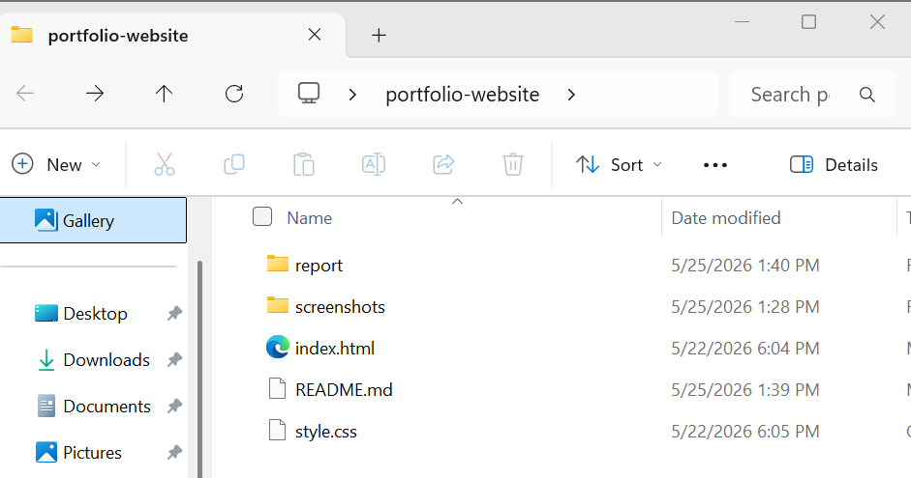
- Figure 2: Website files shown inside the project folder.

Html code
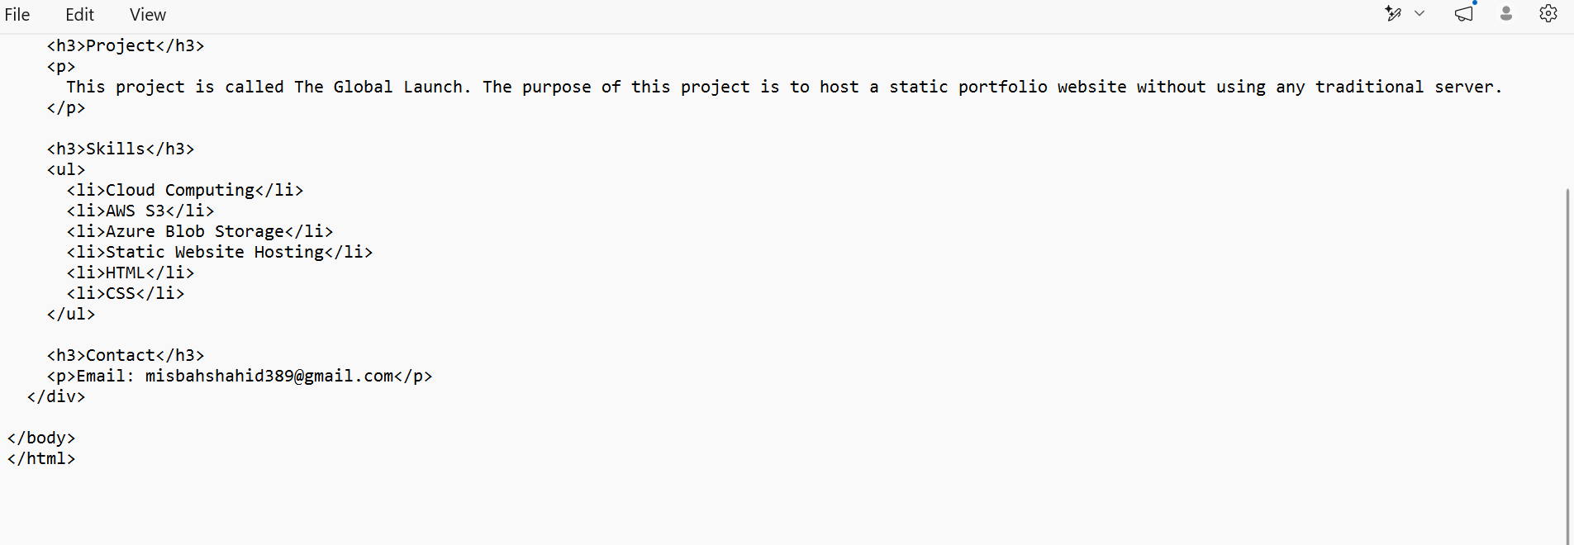

CSS code
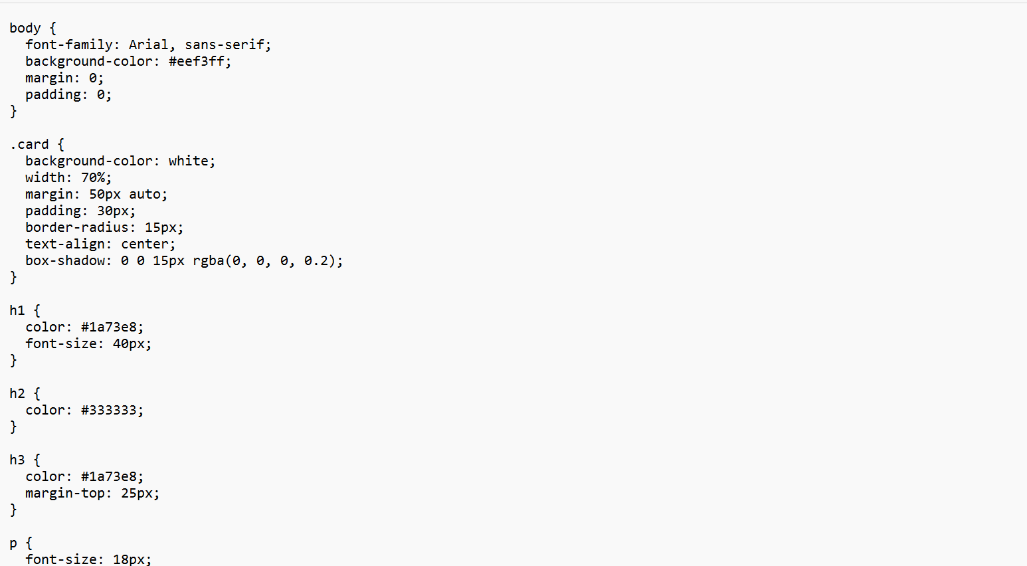
- Figure 3: Portfolio website opened locally in the browser.
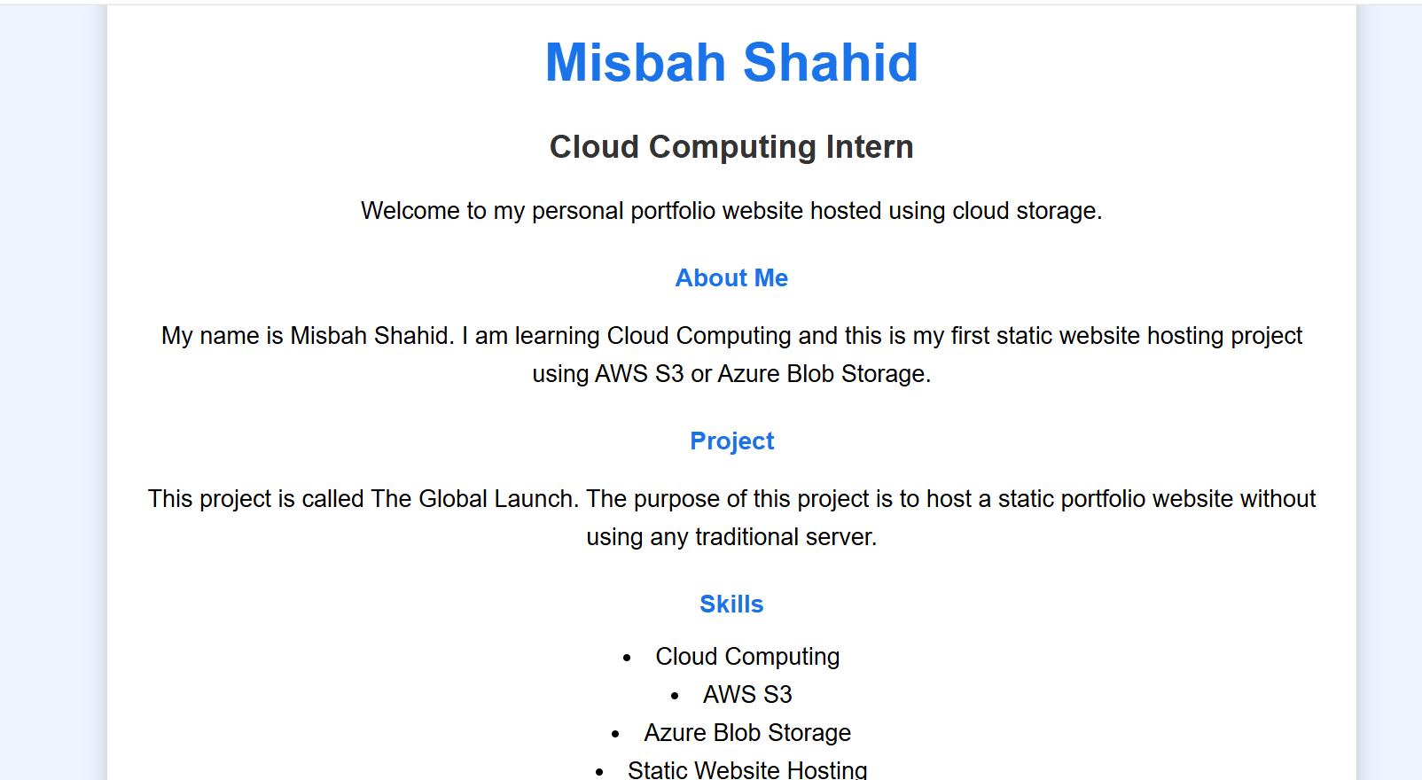

- Figure 4: Azure Storage Account created for the project.
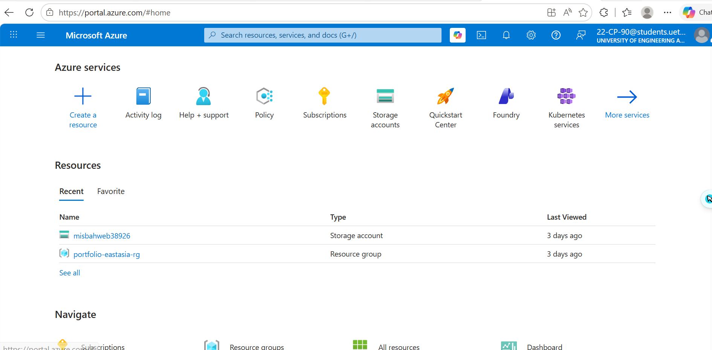
- Figure 5: Static Website Hosting enabled in Azure.
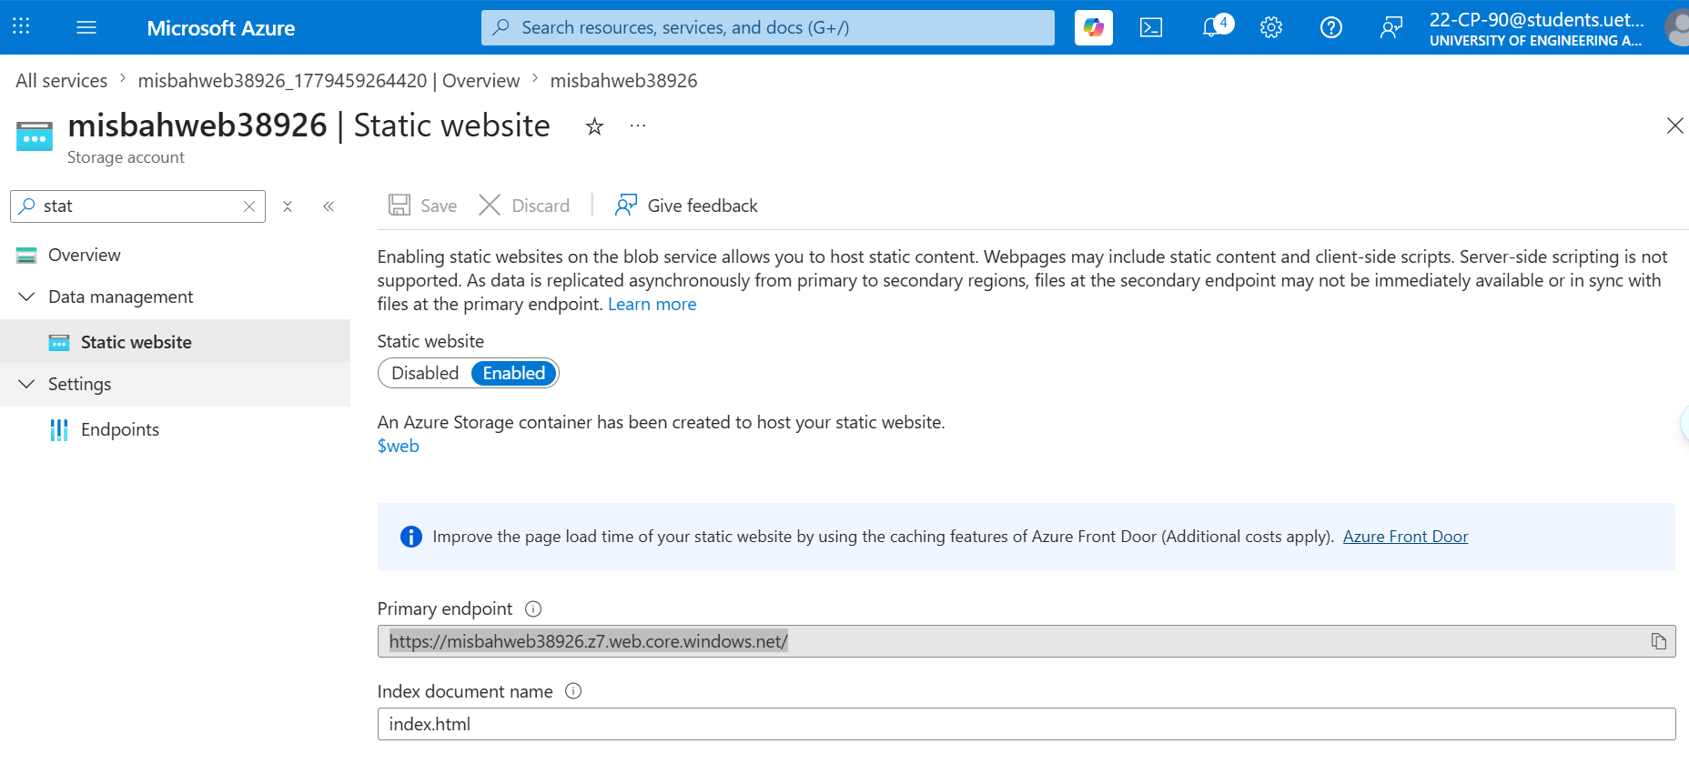

- Figure 6: $web container created by Azure.
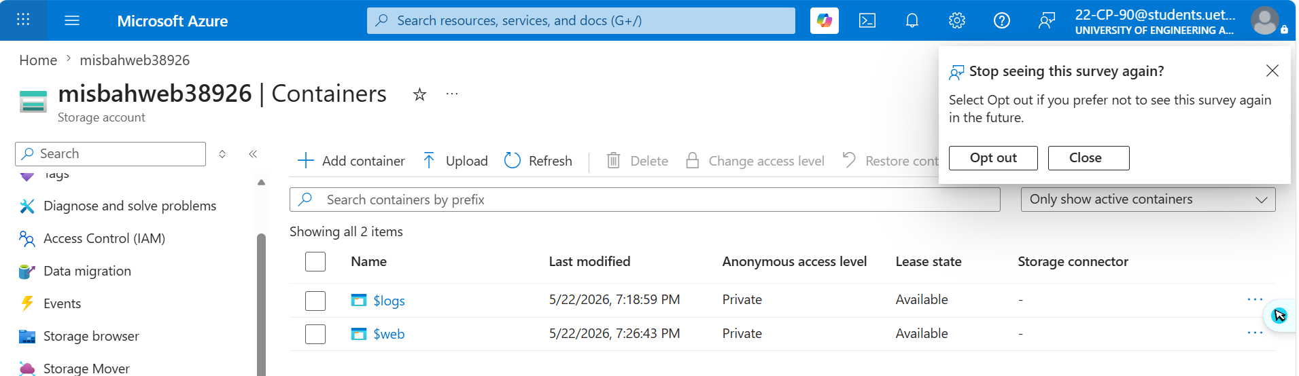

- Figure 7: index.html and style.css uploaded inside the $web container.
- 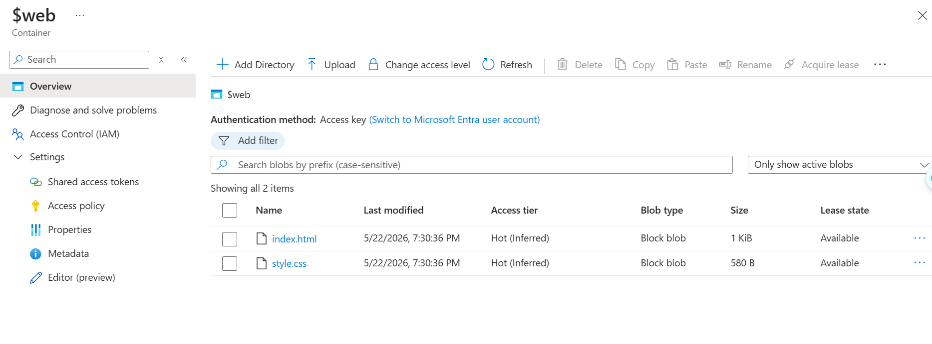
- Figure 8: Final live website opened using Azure Primary Endpoint URL.

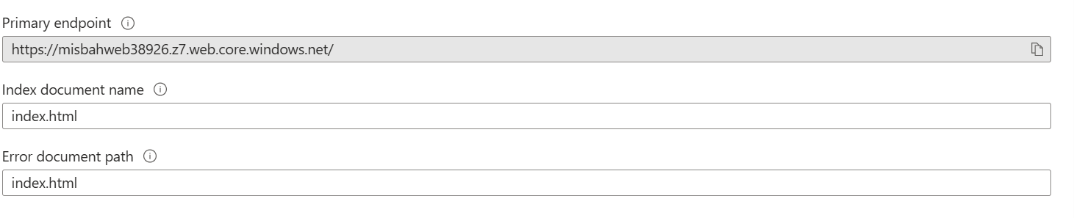

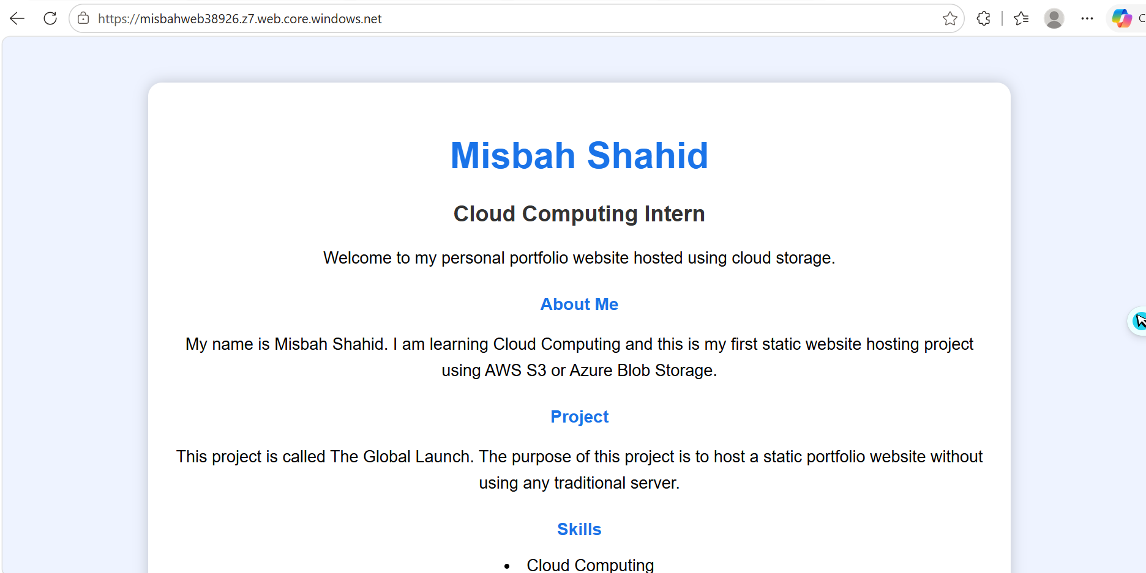
- Figure 9: GitHub repository containing project files and README.md.
- 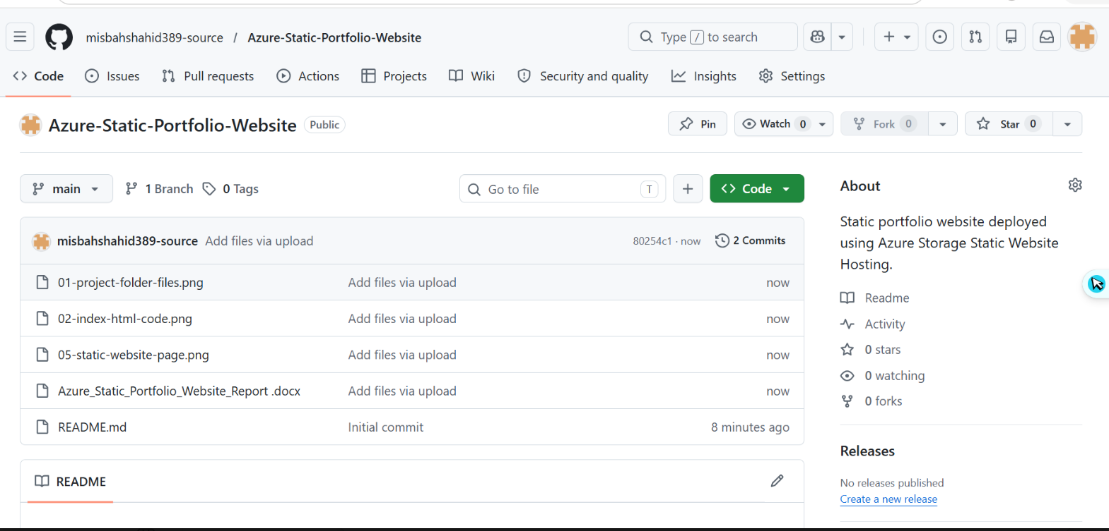

10. Links
Link Type | Link
GitHub Repository Link | Paste your GitHub link here
Live Azure Website Link | Paste your Azure Primary Endpoint URL here

11. Conclusion
This project helped in understanding the process of deploying a static website using Microsoft Azure. Through this project, the website files were created, arranged properly, uploaded to Azure Storage, and deployed using Static Website Hosting. The project also helped in understanding GitHub repository management and README documentation.
Overall, this project demonstrates a simple, cost-effective, and serverless method for hosting a personal portfolio website on the cloud.

12. Appendix: CSS Code
The CSS file controls the visual design of the portfolio website, including colors, spacing, layout, typography, and responsiveness. Paste the final content of your style.css file in this section if your instructor requires the source code inside the report.
/* Paste your style.css code here */

